These three charts were excerpted by Radio World from the FCC’s NPRM and final order.
The first shows actual radio fees for FY2020:
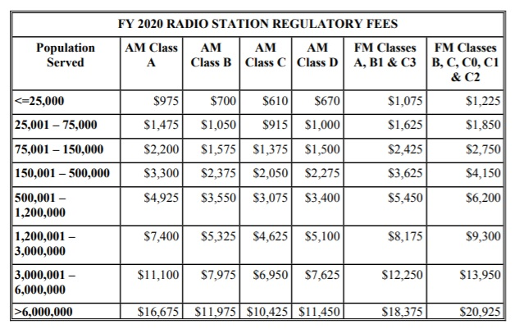
The second shows fees that the FCC had planned for FY2021:
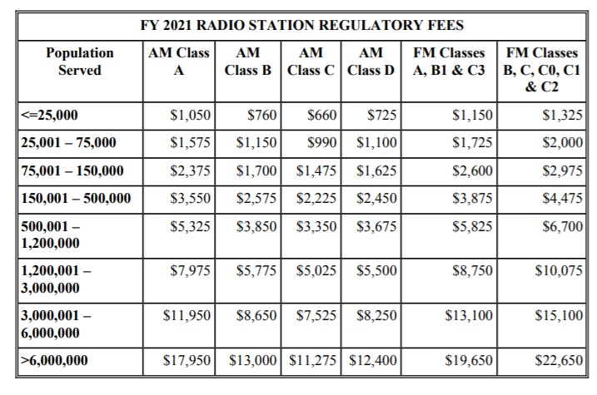
And the third shows the fees finally adopted:
